[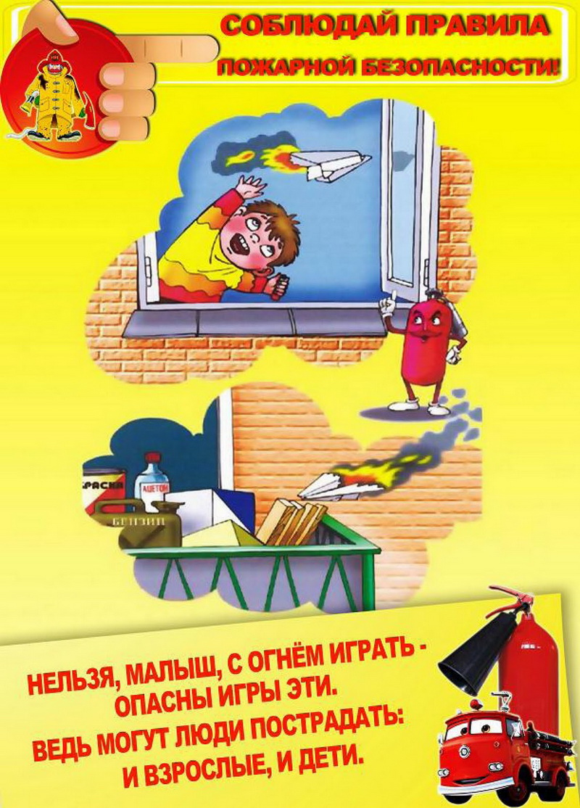](http://мбдоу10.рф/wp-content/uploads/2021/04/pr_poj_bez-006.jpg)

[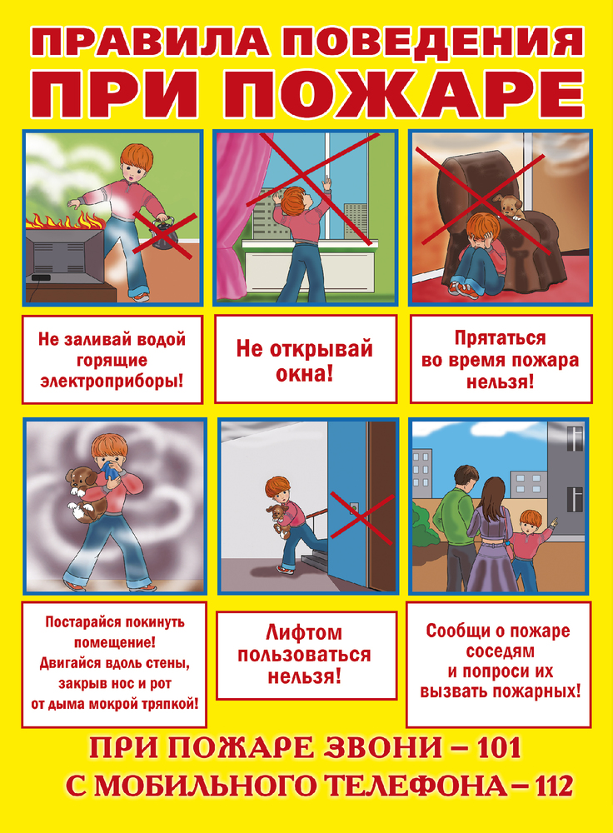](http://мбдоу10.рф/wp-content/uploads/2020/06/1-_1_.jpg)

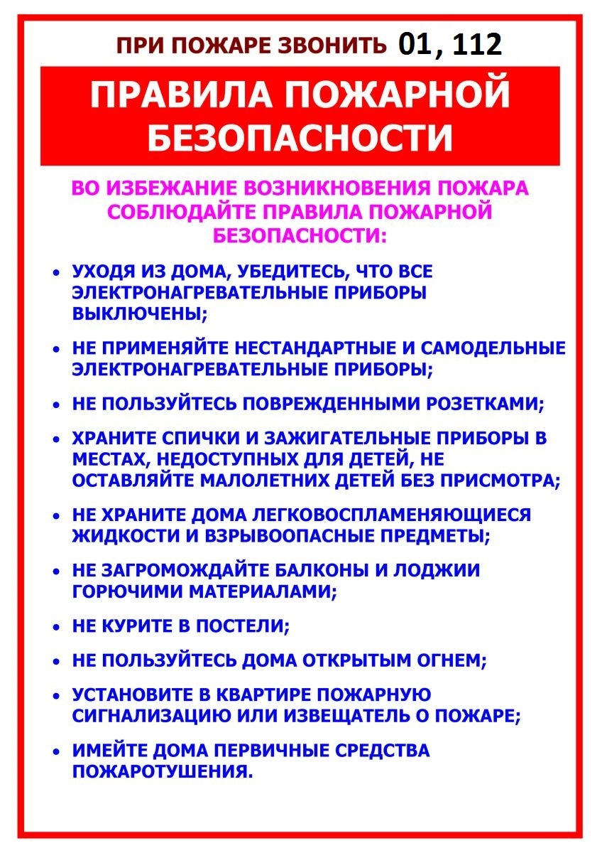

[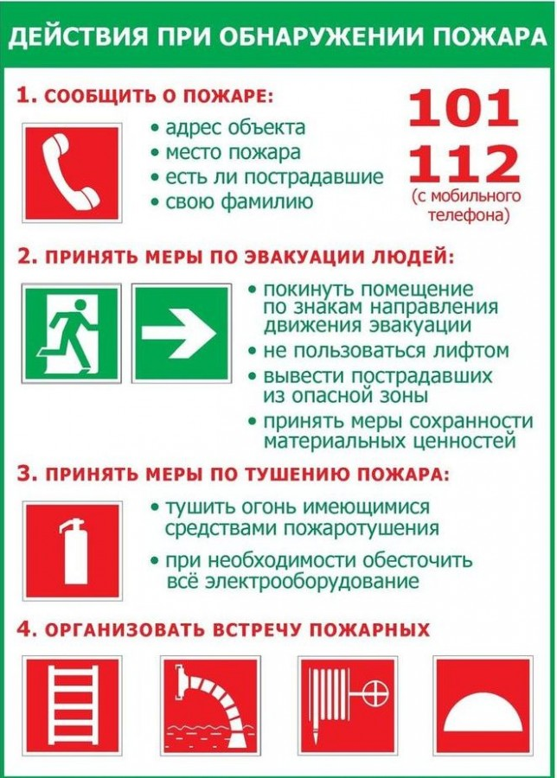](http://мбдоу10.рф/wp-content/uploads/2020/06/deystviya-pri-pozhare.jpg)